Chapter 11, Problem 67.

For the op amp shown in Fig. 11.86, calculate:

(a) the complex power delivered by the voltage source
(b) the average power dissipated by the 12-Ω resistor
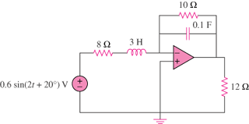

8 Ω

600 sin(2t + 20°) mV

12 Ω

10 Ω

3 H

100 mF

Figure 11.86
For Prob. 11.67.

